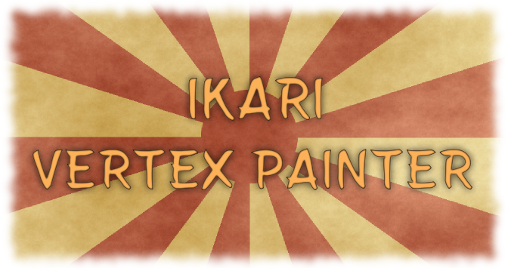
Hi, first of all thanks for buy Ikari Vertex Painter, if you pirated it consider buying it since it’s a cheap asset.

Index of content
1 - Menu Selector. 2
2- Object Properties 3
3- Color Properties 4
4- Tool Properties 5
5- Brush/Bucket Properties 6
6- Paint Properties 7
7- Gizmo Properties 8
2.1 – Selected Object Properties 9

1 - Menu Selector.

If you press on this menu you will be able to change between different menus of the painter.

2- Object Properties
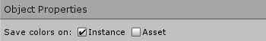
This menu contain the save properties for the meshes you paint.

Instance mode:
This mode allow you to create a new mesh (based on the original) on the scene and paint it, since it's a new mesh is not linked with any assets so it will depend of the scene, save the scene or you will lost the changes!

Asset Mode:
This mode allow you to create and save a new mesh (based on the original) on the disk as .asset extension (Unity extension for assets objects), you can use this mesh in the future for prefabs etc.. since it's saved on the disk.

Also if you copy and paste a painted object with asset mode and use asset mode on the pasted object, both objects will be painted so if you want to paint the copy individually be sure to paint the copy with instance mode for generate a new mesh that is not linked.

If you overwrite a mesh all the other objects with the old mesh will get the new one so be careful with that.

3- Color Properties
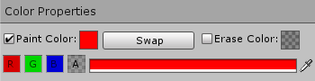
This menu contain the color properties of the tool you are using for paint.

Paint Color:
Paint color is used when you paint something.

Swap Button:
This button allow you to swap the colors between paint color and erase color it's really handy.

Erase Color:
Erase color is used when you use the erase hotkey.

R Button:
This will put the color of the paint/erase color (it depends what you have selected) as red.

G Button:
This will put the color of the paint/erase color (it depends what you have selected) as green.

B Button:
This will put the color of the paint/erase color (it depends what you have selected) as blue.

B Button:
This will put the color of the paint/erase color (it depends what you have selected) as blue.

A Button:
This will put the color of the paint/erase color (it depends what you have selected) as alpha.

Color Field:
This will put the color of the paint/erase color (it depends what you have selected) as the color you selected.

4- Tool Properties
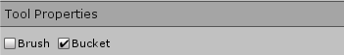
This menu contain the tools you can use for paint.

Brush:
Select the brush.

Bucket:
Select the bucket.

5- Brush/Bucket Properties
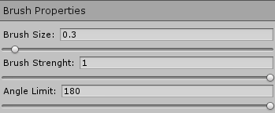
This menu will change based on the tool you have selected, and contains the properties for the tool selected.

Brush Properties:

Brush Size:
Select the size of the brush.

Brush Strenght:
Select the strenght of the brush.

Angle Limit:
Select the limit of the angle you want to paint.

Bucket Properties:
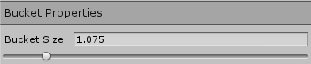

Bucket Size:
Select the size of the bucket.

6- Paint Properties
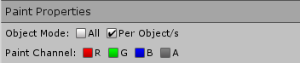
This menu contains the properties of the paint.

Object Mode:

All:
Paint on all the objects.

Per Object/s:
Paint on selected objects.

Paint Channel:

R:
Paint on Red Channel.

G:
Paint on Green Channel.

B:
Paint on Blue Channel.

A:
Paint on Alpha Channel.

7- Gizmo Properties
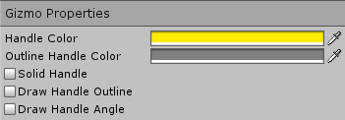
This menu contains the properties of the gizmo/handle.

Handle Color:
Color of the handle.

Outline Handle Color:
Color of the outline handle.

Solid Handle:
Select if you want a solid handle or not.

Draw Handle Outline:
Select if you want handle outline or not.

Draw Handle Angle:
Select if you want to see the angle of the object vertexes.

8 – Selected Object Properties
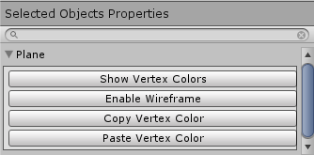
This menu will appear only if you have selected any object and contains the properties of the selected object/s.

Show Vertex Colors / Show Normal:
Show the vertex colors of this object., or the normal material.

Enable Wireframe / Disable Wireframe.
Show the wireframe of this object, or disable it.

Copy Vertex Color
Copy the vertex colors of this object.

Paste Vertex Color
Paste the vertex colors of the clipboard, on this object.

9 –Hotkeys
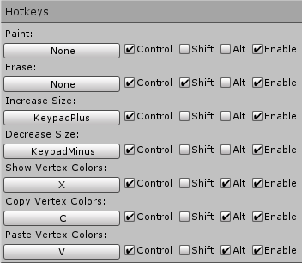
This menu contains the hotkeys of the painter.

If you press on the first button you can select the key you want to use for that hotkey, also you can use modifiers like control, shift and alt/option (Windows/Mac).

If you don't want to use any hotkey you press the enable button.

10 - Uninstaller

This menu contains the uninstaller of the painter.
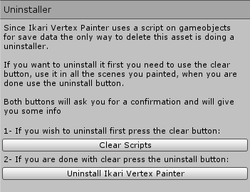
If you want to do a clean uninstallation follow the instructions of this tab.

10 – Help Menu

This menu contains three tabs for different types of help/reports.
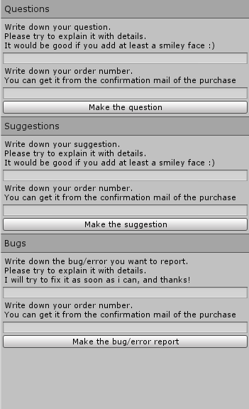

If this tab don't work, send me a email to neo5icekcore@gmail.com with the subject, and please attach your order number or i won't reply.

